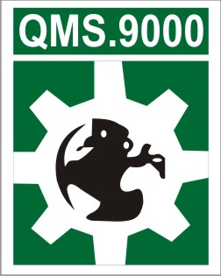
Inquiry Form
Since 1998

Organization Name: ___________________________________________________________________

Address: _____________________________________________________________________________

Phone: _____________________ Fax: _____________________ Website: ________________________

Nature of Business (Sector):______________________________________________________________

Number of Employees: ________________________________________________________

Number of Departments: _______________________ Number of Shift(s): _______________________

Is your organization currently certified on any ISO Standard? Yes No

If Yes, then against which standard (s): _________________; ______________; _______________

Contact Person (Name):________________________________ Designation: ____________________

E-mail: _________________________________ Mobile: __________________________________

If you are interested in any of the following Consultancy / Training then “”

Consultancy Training
ISO 9001 (Quality Management System) | ISO 17025 (Lab Management System)
ISO 14001 (Environment Management System) | ISO 15189 (Medical lab Quality Management)
OHSAS 18001 (Occupational Health Safety) | CE-Mark (Product Certification)
OEKO-TEX (Textile Product Certification) | FBC (Foreign Buyers Compliance, BSCI etc.)
C-TPAT (Customs Trade Partnership against Terrorism) | ISO 27001 (Information security Management System)
SEDEX (Supplier Ethical Data Exchange) | ISO 22000 (Food Safety Management System)
TQM (Total Quality Management) | OD (Organizational Development)
HRM (Human Resource Management) | BSCI (Business Social Compliance Initiative)

Signature: _________________________ Date:_____________________________

